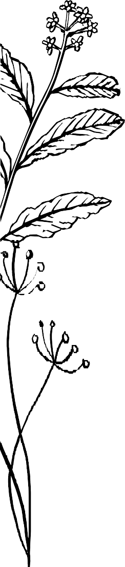
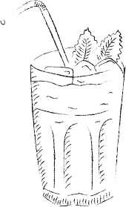

Winter Cocktails

Fig Negroni 14
Plymouth Gin, Campari, Fig Liqueur

Pomegranate Gin Fizz 13
Plymouth Gin, Elderflower, Pomegranate, Cranberry, Prosecco, Soda

Winter Sangria 12.5
Martini Rosso, Burnt Faith Peach Liqueur, Fever-tree Blood Orange Soda

White Negroni 9.5
Botivo Botanical Aperitivo, Martini Extra Dry, Plymouth Gin

Picante Spritz 12.5
Altos Plata Tequila, Beesou honey, Green Chilli, Lime, Soda

Yuzu Honeybee 14
Jamesons Irish Whiskey, Beesou Honey, Yuzu Sherbet,
Fever-tree Ginger Ale

Old Fashioned 13.5
Buffalo trace Bourbon, Demerara sugar, Orange bitters
Also available, Havana 7 Rum Old Fashion
Or a Mezcal Old Fashion

Non-Alcoholic Cocktails

Amalfi Spritz 0% 9.5
Lyre’s Italian Spritz 0.0%, Fever-tree Blood Orange Soda

Negroni 0% 11
Tanqueray 0.0%, Lyre’s Italian Spritz 0.0%,
Three Spirit Livener 0.0%

Before you order your drink, please inform a member of the team if you have any allergies or intolerances.
Spirit & wine measures vary by serve.

